Development and Validation of a Novel Posture Monitoring System(v.2.1-involves changes in grammar in everything below intro and addition of wrap fun formula, thethaAccx, and explanation for form, and patients’ data)

Sai Sri Harini.C   
*Biomedical Department*  
*PSG College of Technology*Coimbatore, India

Syed Althamish ur Rahman   
*Biomedical Department*  
*PSG College of Technology*Coimbatore, India

Sarvesh Rajavel.R  
*Biomedical Department*  
*PSG College of Technology*Coimbatore, India

Kefira Jane.J  
*Biomedical Department*  
*PSG College of Technology*Coimbatore, India

*Abstract*—In contemporary society, posture-related musculoskeletal disorders are on the rise due to extended periods of sedentary behavior and repetitive tasks with people spending most of their time slouching and hunching over desktop screens, tablets and mobile phones. This continuous behavior over extended periods of time causes severe upper and lower backpain that subsequently leads to cervical spondylosis and bulging of lumbar discs. In response to the prevalence of this issue, we have developed a posture monitoring system realized through a shoulder strap to capture the siting posture of individuals. This is achieved by utilizing 3 IMU sensors to monitor and Machine Learning Algorithms to classify. The classification algorithms were trained with data acquired from 12 healthy individuals and the bests chosen one is the KNN algorithm with an accuracy of 99%. The system was further validated with a real time validation routine and was identified with 80% accuracy.

Keywords—IMU, Spinal Posture, Data Classification

# Introduction (*Heading 1*)

Sitting is one of the most common postures in daily life [1.2-7], with studies indicating that people spend around six hours sitting each day. Consequently, back pain has become a widespread and troubling issue, now ranking as the third most common reason for individuals to seek medical attention [3.?]. Approximately 70-80% of those experiencing back pain attribute it to poor posture [d1?]. Chronic back pain develops gradually due to sedentary behavior, often exacerbated by prolonged use of digital devices. This has resulted in 15-19% of people suffering from upper back pain and 60-70% from lower back pain [d1?].

The most frequent activity while sitting is using mobile phones, with an estimated 4.77 billion users worldwide as of 2017. This number was projected to increase to 5.07 billion by 2019 [2.1]. As more essential services are integrated into smartphones, and with the growing number of mobile applications, this has further promoted a sedentary lifestyle. Alarmingly, a recent study reveals that looking down at a phone is comparable to placing 60 pounds of pressure on the neck [4.1]. Correspondingly, another study highlighted that a condition known as "Text Neck," caused by 60 pounds of neck pressure, can lead to Kyphosis [2...?]This disease is an excessive spine curve because of abnormal rounding of upper back. which can lead to breathing problems that may eventually require a surgical treatment.[4.?].

Chronic Low Back Pain (CLBP) is another significant cause of disability, affecting similar populations across various countries and cultures, with one in five adults experiencing CLBP each year [1.2]. In industrialized nations, chronic pain is rapidly becoming the foremost health issue, contributing to annual low back pain costs of $100-$200 billion [1.4].

Acute back pain, which often results from injuries like muscle strains or ligament tears due to activities such as heavy lifting or sudden movements, can also lead to considerable discomfort and mobility limitations [d.?]. Back pain significantly affects an individual’s quality of life, reducing productivity, limiting movement, and causing emotional distress. Studies have found that slouched or hunched posture not only reduces energy levels but also negatively impacts mental well-being, such as happiness and depression [2.4]. Poor posture also affects workplace productivity, with approximately 75% to 85% of worker absenteeism being attributed to recurrent or chronic back pain [1.6].

Despite its prevalence, simple preventive measures can effectively mitigate these disorders. According to medical research, most cases of severe Kyphosis can be treated and prevented through exercises aimed at improving posture and maintaining a straight spine [4.2]. A study by Robertson et al. [5.1] found that musculoskeletal risk decreased after 16 months of ergonomic posture training for seated individuals. Further studies by Choobineh et al. [5.2] and Menendez et al. [5.3] demonstrated that ergonomic interventions could reduce musculoskeletal discomfort and related symptoms. Additionally, research by Taieb-Maimon et al. [5.5] showed that posture risk diminished after three weeks of an experiment using a camera to display the seated individual’s sagittal posture. Therefore, maintaining proper spinal posture is possible and essential, which is the goal of our system’s design.

Several systems have been developed to address this issue, comprising three main components: data collection, data analysis, and feedback [4.?]. Our system incorporates all these elements, with a particular focus on analyzing the collected data while in a seated position.

# System Architecture

Our system's operation primarily depends on the data acquired by IMU sensors placed on the body, which are then pre-processed to extract features. These features are then fed to a classifier to identify the user's sitting posture, therefore notifying the user.

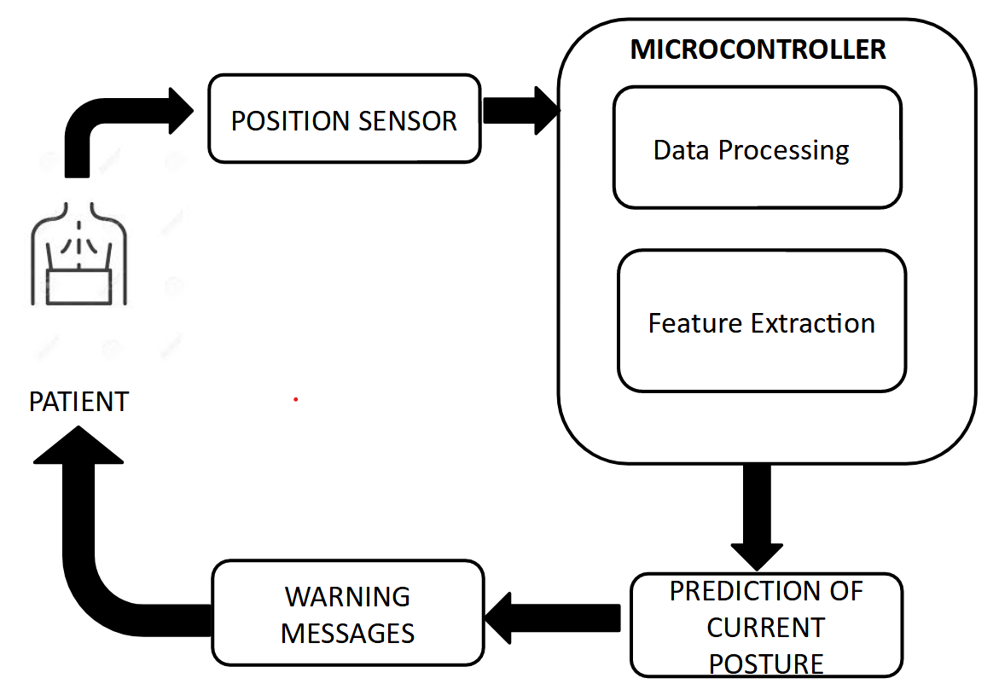

## Design:

Our system is designed to extract movement and orientation-related data during sitting posture from three different locations. These locations are:

* The Acromion Process
* The T5 vertebra
* The Sternum (SAII)

The Acromion Process and T5 vertebra were chosen due to their remarkable accuracy in existing posture monitoring systems that use IMU sensors. This is understandable due to the significant deviation in location and orientation during postural changes. The thoracic junction is used to counterbalance the system's bias toward the posterior of the body with the T5 vertebra. This location proved to be the best for extracting data from the anterior of the body.

The placement of these sensors was achieved using a Neoprene Velcro shoulder strap, as described in Figure 1. This adjustable shoulder strap covers all three mentioned areas and was used to embed the sensors within. Care was taken to avoid letting the shoulder strap's influence affect the user's normal posture. The Acromion and T5 sensors were fixed, whereas the chest sensor was adjustable to relocate it to the correct position for individuals with different body widths. The sensors used for this purpose were MPU-6050s, which are capable of acquiring 6 degrees of freedom (DoF), namely, acceleration and rotational speed on all three axes. This data could be transmitted through the I2C medium, allowing fast multi-device communication, aiding our purpose, and operating at low power.

The processing unit was located near the sensors and was embedded within the strap near the Acromion Process, as this area had enough space to hold the MPU. The processing unit was connected to the sensors via a series of wires designed to align with the strap's structure. Some limitations were noted in its placement, with reports of discomfort due to its inflexible structure. The objective of our system is to improve processing and classification; therefore, the processing unit's size was reduced as much as possible but ideally needs to be flat and flexible with zero protruding height. The Raspberry Pi Pico was chosen for its small size and ample memory (20kb SRAM). It also includes built-in libraries for the future prospect of embedding ML algorithms. Additionally, it is low power.

A BLE module was used to transfer relevant data to the classifier on the PC. The HC-05 module was selected for its accessibility to high speeds and low power operation.

The classifier was run in the background on the user’s PC. It classified data received from the BLE module and presented relevant information to the user as needed. The classifier chosen for this purpose was KNN, as it demonstrated better performance in a set of experiments detailed in the following sections. The classifier took a mean time of 1.5 seconds for inference.

## Operation

Once the shoulder strap embedded with the sensors and processing unit is worn by the user, they are expected to perform a calibration routine. This routine is conducted to eliminate the zero-error arising from the gyroscopic measurements for each user. During this 10-second routine, the user sits in a static neutral posture, as depicted in Figure 1. The zero-error bias is calculated by averaging the static gyroscopic signal.

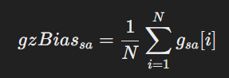Each sensor outputs a 6-DoF measurement, namely, acceleration and rotational speed on all three axes. Each sensor is sampled at 45Hz, given the processing limits of the Pico. While the acceleration signal is not pre-processed, the gyroscopic signals are altered by subtracting the zero-error bias value calculated during the calibration routine. This adjustment allows the gyroscope to output true zero values. The processing unit then acquires these signals and processes them to extract new information, known as tilt. The tilt is calculated in two ways: using a complementary filter and using only acceleration signals.

The complementary filter considers both acceleration and gyroscopic observations to calculate the tilt using the formula depicted below. The complementary filter effectively combines the low-frequency stability of the accelerometer (which measures tilt based on gravity but is susceptible to noise from linear movements) with the high-frequency responsiveness of the gyroscope (which tracks rotation but drifts over time). This fusion helps maintain a more reliable and stable estimate of tilt angles, reducing noise and drift. It applies a weighted combination of the accelerometer and gyroscope data. The optimal weight chosen is 0.95. The formula is further advanced to wrap the signal around +180 to -180 degrees to better compensate for the drift accumulated by gyroscopic readings. Despite the complementary filter's advantage over the acceleration-based tilt, due to the static nature of sitting postures, both methods are taken into account.

* θX​[n] is the filtered tilt angle for the X-axis at the current loop iteration.
* θX[n−1]\theta_X[n-1]θX​[n−1] is the tilt angle from the previous iteration.
* θAccX\theta_{\text{AccX}}θAccX​ is the angle derived from accelerometer data for the X-axis, calculated using
* θ˙GyroX​⋅Δt is the change in angle from the gyroscope data between sampling period, where θ˙GyroX​ is the angular velocity from the gyroscope for the X-axis, and Δt is the time step between each sample.
* α is the complementary filter weight which we’ve found best operated at a value of 0.95

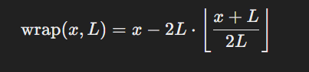Where wrap is defined as above, where:

x is the input angle.

* L is the limit (e.g., L=180Deg)
* ⌊y⌋ is the floor function, which returns the greatest integer less than or equal to y.

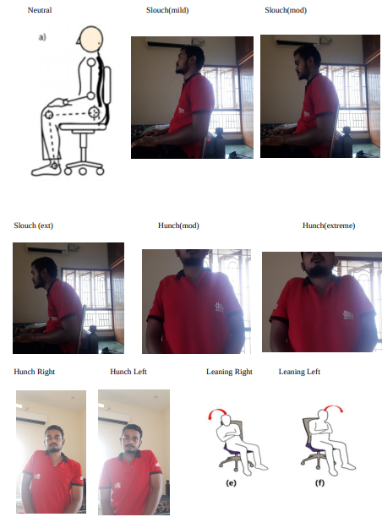

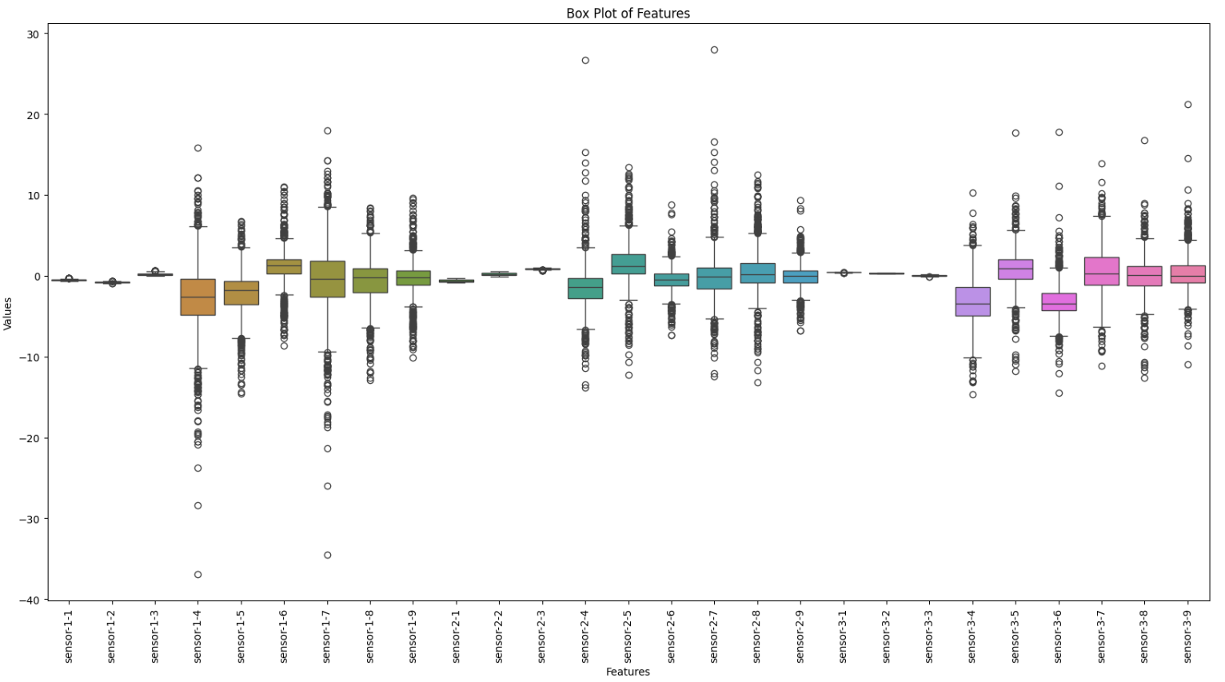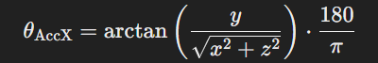

Where thethaaccx is the x axis tilt derived from acceleration data of a sensor [ref?]

From all the extracted features, the meaningful ones are sent to the classifier via the BLE module using a UART module to communicate with the processor. The classifier then identifies the user's posture and displays it to them via an application.{saii}

# Feature Selection and Training{saii}

For the purpose of analyzing the data and training the ML algorithms with respect to it, appropriate data needs to be acquired. The following section highlights how that data was acquired.

## Data set Acquisition:{saii}

The data was acquired from 12 healthy individuals with a mean age, height, and weight of 23y, 166cm, and 70Kg, respectively. Among 12 individuals 8 were males and 4 were females. Their respective data is presented in Table 1.

The data acquisition routine began with the user undergoing the calibration routine outlined above. They were then asked to relax and begin with the first posture, which was neutral. Each user was seated on a stool with no back support and was requested to remain in a specific posture for 10-15 seconds. The user was asked to replicate the postures depicted in Figure 4. The order of the postures is as follows:

- Neutral

- Mild Slouch

- Moderate Slouch

- Extended Slouch

- Mild Hunch

- Extended Hunch

- Right Hunch

- Left Hunch

- Lean Right

- Lean Left

Approximately 94,000 data points were recorded, with about 9,000 data points per posture.

|  |  |  |  |  |  |  |  |  |  |  |  |  |  |  |
| --- | --- | --- | --- | --- | --- | --- | --- | --- | --- | --- | --- | --- | --- | --- |
|  |  |  |  |  |  |  |  |  |  |  |  |  | Mean | Variance |
| Age | 20 | 21 | 21 | 21 | 21 | 20 | 47 | 18 | 22 | 20 | 19 | 24 | 23 | 60 |
| Height(cm) | 180 | 164 | 169 | 170 | 168 | 165 | 157 | 157 | 167 | 159 | 165 | 165 | 166 | 40 |
| Weight(kg) | 80 | 57 | 86 | 75 | 85 | 64 | 82 | 56 | 64 | 51 | 70 | 72 | 70 | 141 |

* L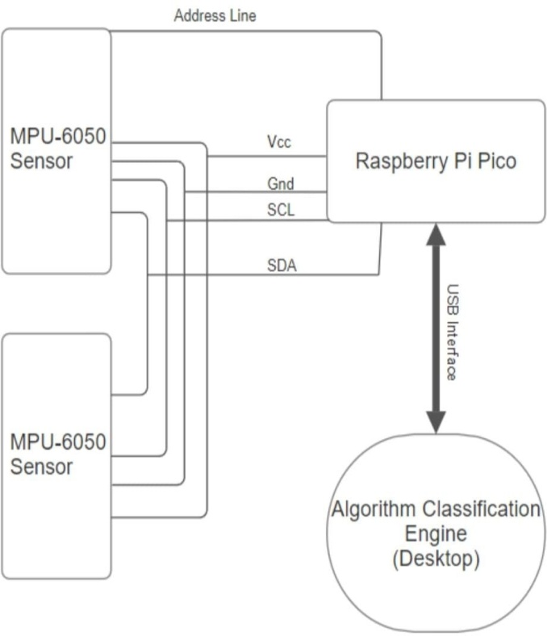ean left

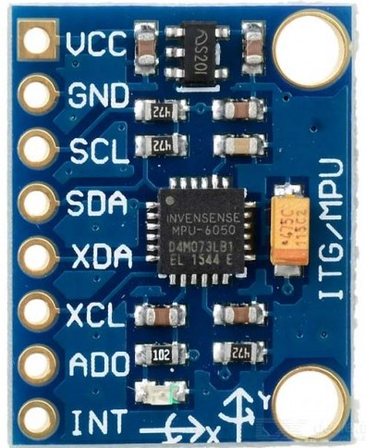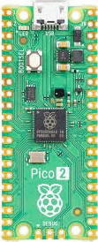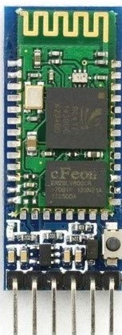

## Feature Set Selection:{saii}

Including the raw data measurements from each sensor and the tilt angles derived using two different methods, there is a total of 33 features. Each sensor provides 11 features: 6 DoF raw data measurements and 5 tilt angles. The X and Y axes are derived from both complementary filter and acceleration data, while the Z axis is derived only from acceleration data. Some features were deemed redundant, as detailed in Table 5.

The ideal posture monitoring system would be a stand-alone, wearable system that does not require external processing. To support this goal, a feature reduction/selection process was carried out to determine the most relevant features. The methods used for feature selection and extraction are discussed below:

-

-

-

## Classifier Selection:{saii}

Multiple ML models were tested to find the best-performing one. The KNN model, which used only 2 or 3 user-selected features (complementary tilt angles in the X and Y axes), provided 94% accuracy. The performance details of each classifier are shown in Table 9. The training and testing datasets were divided by a 0.75 ratio.

# Result{saii}

Our system is designed to efficiently and accurately monitor sitting posture. The final design comprises three sensors whose raw data is used to extract a derived feature known as tilt. The complementary filter's tilt derivation was found to be the best-performing variation. The KNN classifier, which provided 94% accuracy, was deemed the best model for identifying posture. Although the classifier was trained with a limited dataset of only 12 people, the system would benefit from more data. It was also found that an additional third sensor on the posterior of the body reduced the classifier's accuracy, rendering it unnecessary.

# Conclusion:{Saii}

Posture monitoring with IMU sensors is a challenging but achievable task, with our system providing 94% accuracy. This system is ideal for monitoring sitting posture during seated work. IMU sensors provide maximum privacy while maintaining decent accuracy. Due to its low-power nature, the system can be used anywhere, acquiring postural data over long periods with minimal effort from the user. However, the design could benefit from improvements, such as reducing the size of the processing unit and increasing its flexibility through the use of flexible electronics. The system's performance with the general population could improve with access to a larger and more diverse dataset, including individuals of varying ages, weights, and heights. Furthermore, the calibration routine at the start of each monitoring period could be replaced with more efficient, less time-consuming methods that do not impose restrictions on the user. The shoulder strap could be replaced with textile-embedded electronics to enhance user comfort. Finally, incorporating the ML algorithm into the processing unit would allow the system to function as a stand-alone device.

##### References

1. G. Eason, B. Noble, and I. N. Sneddon, “On certain integrals of Lipschitz-Hankel type involving products of Bessel functions,” Phil. Trans. Roy. Soc. London, vol. A247, pp. 529–551, April 1955. *(references)*
2. J. Clerk Maxwell, A Treatise on Electricity and Magnetism, 3rd ed., vol. 2. Oxford: Clarendon, 1892, pp.68–73.
3. I. S. Jacobs and C. P. Bean, “Fine particles, thin films and exchange anisotropy,” in Magnetism, vol. III, G. T. Rado and H. Suhl, Eds. New York: Academic, 1963, pp. 271–350.
4. K. Elissa, “Title of paper if known,” unpublished.
5. R. Nicole, “Title of paper with only first word capitalized,” J. Name Stand. Abbrev., in press.
6. Y. Yorozu, M. Hirano, K. Oka, and Y. Tagawa, “Electron spectroscopy studies on magneto-optical media and plastic substrate interface,” IEEE Transl. J. Magn. Japan, vol. 2, pp. 740–741, August 1987 [Digests 9th Annual Conf. Magnetics Japan, p. 301, 1982].
7. M. Young, The Technical Writer’s Handbook. Mill Valley, CA: University Science, 1989.
8. K. Eves and J. Valasek, “Adaptive control for singularly perturbed systems examples,” Code Ocean, Aug. 2023. [Online]. Available: <https://codeocean.com/capsule/4989235/tree>
9. D. P. Kingma and M. Welling, “Auto-encoding variational Bayes,” 2013, arXiv:1312.6114. [Online]. Available: <https://arxiv.org/abs/1312.6114>
10. S. Liu, “Wi-Fi Energy Detection Testbed (12MTC),” 2023, gitHub repository. [Online]. Available: https://github.com/liustone99/Wi-Fi-Energy-Detection-Testbed-12MTC
11. “Treatment episode data set: discharges (TEDS-D): concatenated, 2006 to 2009.” U.S. Department of Health and Human Services, Substance Abuse and Mental Health Services Administration, Office of Applied Studies, August, 2013, DOI:10.3886/ICPSR30122.v2